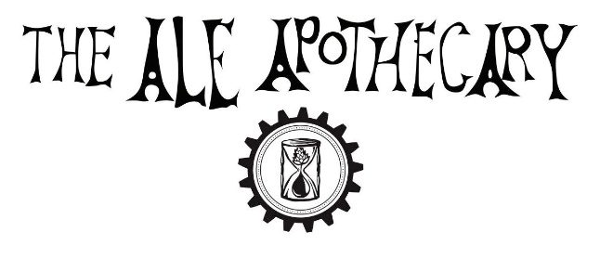
2024 ALE CLUB
MEMBERSHIP DETAILS
Annual membership costs $325
- Annual Membership costs $325 (January 1st, 2024 – December 31, 2024)
- Twelve 750ml bottles of our favorite beers selected specifically for Ale Club members. We save the best of our 2024 beer for club members.
- The membership case is released IN FULL at our Annual Ale Club Celebration in November 2024.
- Members have the first chance to purchase additional non-Club, limited release bottles released every quarter in 2024 at a 15% discount. We also offer free “members only” tastings for club members at our tasting room for each release. For 2024, we plan to have numerous small volume offerings every quarter, some new releases and some vintage bottles from our library. These are first-come first-served regarding availability.
- Invitation for you and a guest to our Annual Ale Club Celebration & Bottle Share.
- 15% off in our tasting room, all the time.
- First right to renew for 2025 Ale Club.
- Automatic enrollment in our soon-to-be launched PharmTeam program for our new line of ‘clean’ draft beer.
BEER STORAGE & PICKUP
- We encourage all members to attend our annual beer release & distribution on the 1st weekend in November 2024. It’s our favorite event of the year! Tasting is included with beer pickup. If members are unable to attend, your beer will be stored securely at our cellar on the west side of Bend (30 SW Century Drive, Suite 140) until Feb 1st, 2025.
- We offer additional (non-club) bottle purchases every quarter for members only, discounted 15%. Purchases made online will be stored for 1 month or you may purchase an annual storage fee for $50. Club case storage is included in the membership, extra purchases do not include long-term storage. Beers may be picked up in the tasting room during normal open hours or by appointments scheduled in advance via email (paul@thealeapothecary.com)
- Beers can be picked up in person or by a named PROXY. A Facebook group created by one of our members is a good place to find a proxy if you need one. You can access the Ale Apothecary Beer Club page HERE
- Unfortunately, due to legal reasons, WE CANNOT SHIP BEER.
MEMBERSHIP TERMS
- All beer purchased and/or obtained through your Ale Club membership is for your own consumption, Not for resale. We reserve the right to cancel any membership without refund in the event of a member selling beer purchased or received as part of the membership.
- We reserve the right to sell our beer, including unsold or unallocated membership bottles, through our tasting room, special events and wholesale channels. In good faith, we make every effort to keep these beers exclusive to the Ale Club.
- Beer not picked up by the deadline will be returned to The Ale Apothecary inventory.

OUR ALE CLUB IS THE MOST IMPORTANT PART OF OUR BUSINESS. THANKS FOR YOUR SUPPORT!

